**Institute of Technology Tralee**

**BSc. in Computing with Specialism (Group 3) - Year 1**

**Continuous Assessment #1**

**Date: 5/11/14**

**Time: 10a.m. – 12p.m.**

**Introduction to Programming**

**Instructions:** Attempt the following question. You should use the JCreator IDE for coding. When you are finished you must print out your code for correction.

**________________________________________________________**

**Q1.**

Irish Water, the recently formed state water services provider, have issued all households in the country with a form to determine whether or not the household is a customer of Irish Water and, if it is, to determine the annual water charge that will apply for the household.

Write a Java program that first of all asks the user two questions. The first question will ask if the household has its own private water supply and the second question will ask if the household has a septic tank.

If the user answers “y” (yes) to both of these questions then the household is not a customer of Irish Water and the program will simply issue a message in this regard, indicating that the annual water charge for the household is €0.00

If, however, the user answers “n” (no) to either (or both) of the questions asked, then the household is a customer of Irish Water and then the program will proceed to ask the user for some further information.

The next question will ask whether the household has a meter installed. If the user answers “n” (no) to this question then the user will be told that they will be charged a flat annual fee of €212 for water services. If the user answers “y” to this question then the user will be asked how many litres of water they have used in the past year (you can take it this will be a **whole number**). Based on the number of litres used, the customer will be charged at the rate of 0.224 cent per litre (make this rate a **constant** in your program), but they will be given a free allowance of 30,000 litres per year. So for example, if the user enters 87,000 litres then the charge will be (87,000-30,000) x 0.00224 = €127.68. The cost for the household will then be displayed correct to **2 decimal places**.

Using the test values as indicated in the screen shots below, the program should give you **exactly** the following output when it runs, including banners, blank lines, units etc.

Also note that there will be a few marks awarded for the use of **meaningful variable names**, having a  **single and multi-line comment at the top of the program** and for **proper indentation** in the coding of the program.

**Sample Screen Shots**

**The user answers “y” to the first question asked, “y” to the second question so there is zero charge**

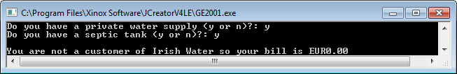

**The user answers “y” to the first question asked, “n” to the second question, “y” to the third question so the charge is based on the litres supplied**

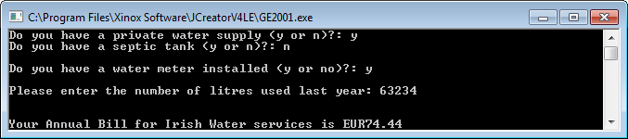

**The user answers “n” to the first question asked, “y” to the second question, “n” to the third question so a flat fee of €212 applies**

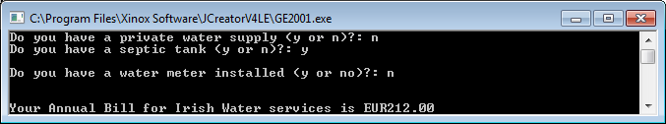

**The user answers “n” to the first question asked, “y” to the second question, “y” to the third question so the charge is based on the litres supplied**

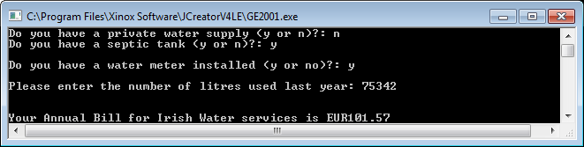

**The user answers “n” to the first question asked, “n” to the second question, “y” to the third question so the charge is based on the litres supplied**

